

Case Study: Production Process

SAP Business One 9.2, version for SAP HANA
SAP Business One 9.2

iNTRODUCTION
In this case study, you will perform the following tasks:
- Create a resource
- Create a bill of material
- Create the production documents needed in the production process

PREREQUISITE:

 | PREREQUISITE
- Use the database of your institution with SAP Business One 9.2, version for SAP HANA or SAP Business One 9.2
- Replace ## with your personal user number (ex. 01 – 30)

Your Roles


OEC COMPUTERS

Name: George Smith
Function: Production Manager

Tip: You can use the Look Up Menus function in SAP HANA or the Search function in SQL to find the relevant paths.

Task 1
Create a resource for a technician employee.
Create the resource with the following number: R1101##

Resources Resource Master Data:
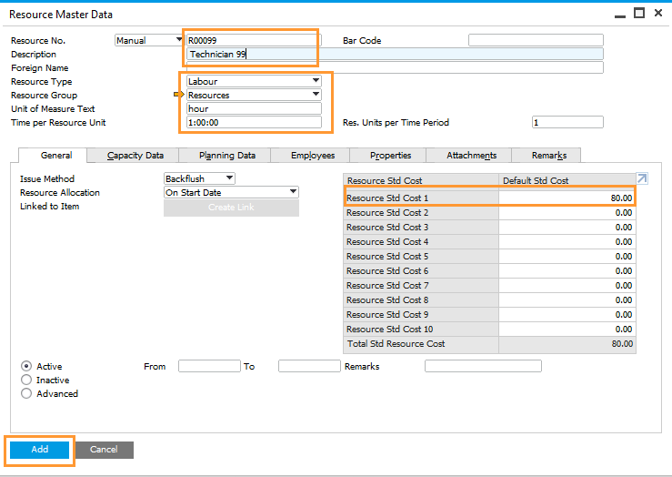

Technicians can be measured by the hour.
Attach two employees to the Resource Master Data.
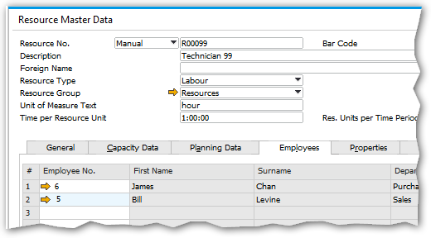

Task 2
Create a bill of material (BOM) for a laptop item.
Create your item with the following number: G1301## and the description Laptop ##
Hint: You first need to create item master data for the BOM.
Set the laptop price to the total price of its components.

First, create item master data for the laptop:
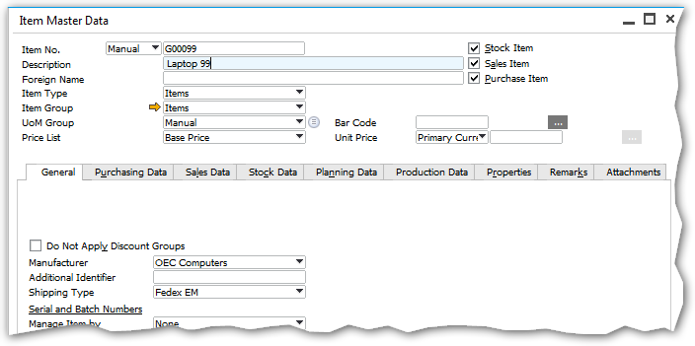

Then add a bill of material as follows:
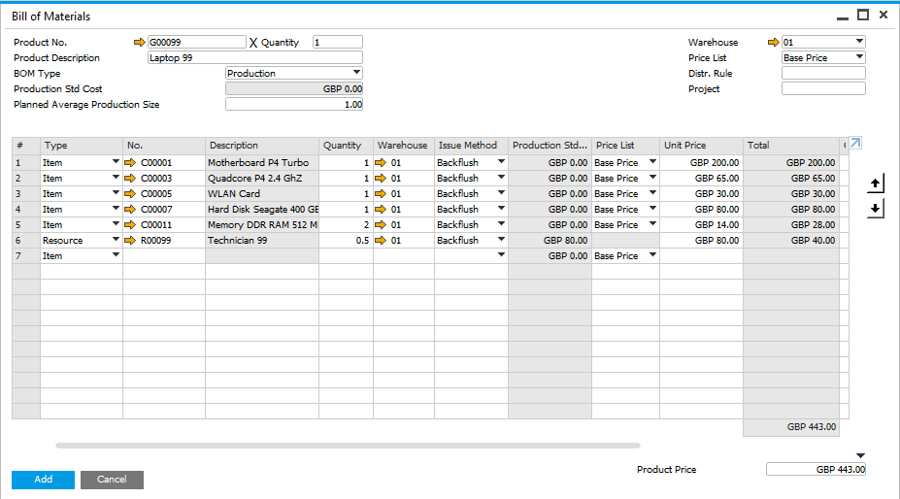
Choose the downward arrow to copy the total of all item prices and resource costs to the product price.
The unit of measure for the resource is hour; in this case, it takes one half-hour for the technician to assemble 1 laptop.
Resource cost

Information: The item prices are drawn from the price list in each row (Base Price in this example). The resource price is the cost of the resource.

Make sure that the sales price list equal to 150% of the base price list.

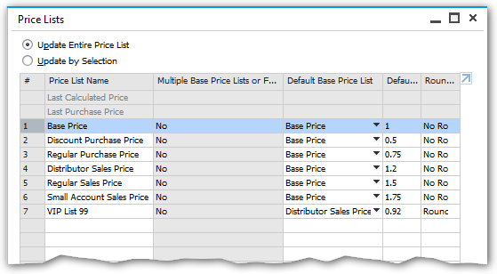

Task 3
Add a suitable production order.
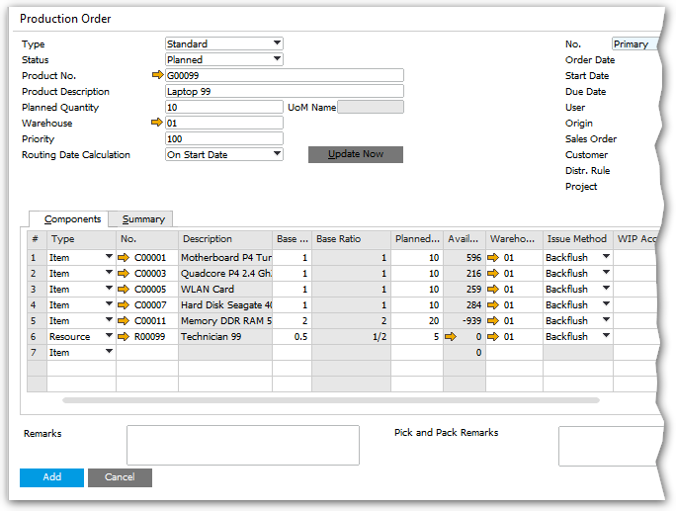
Quantity needed to produce 10 units = base quantity X 10

What is the total run time of the production order? Please explain your answer.
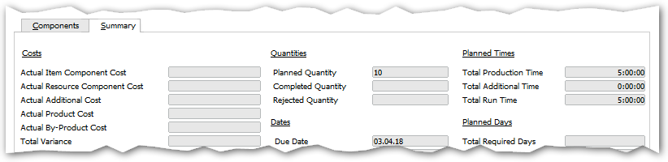

Answer: (The total run time is measured according to the run time of all the resources needed for the entire order. Since the order is for 10 units and it takes 0.5 hours to assemble 1 unit, the total production time is 5 hours.)

Task 4
Create the steps necessary to remove the component items from inventory and add the item produced to inventory.

In order to proceed in the production process, you first need to change the status of the production order from Planned to Be Released and update the document.
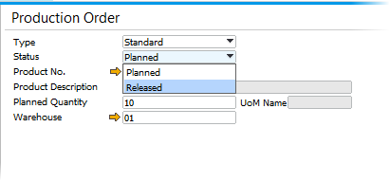
In the context menu of the production order, choose the option Report Completion:
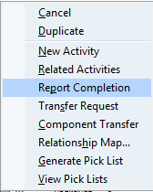
If you have an error like:
Please add the Resource WIP Account in the tab “Resources” in the “GL Account Determination” window
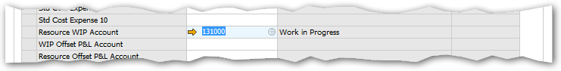

A receipt from production will be opened for 10 laptops, which you can then enter into the system.
Information: Note that an issue for production document will also be generated in the background to remove the component items from inventory.

How does the issue method affect the process of production?
Answer: (Since all rows of the production order are set to the issue method Backflush, the user only needs to enter a receipt from production document. The system will add an issue for production document automatically.

This way, the components of the laptop will be issued from inventory and the produced laptop item entered into inventory at the same time.)
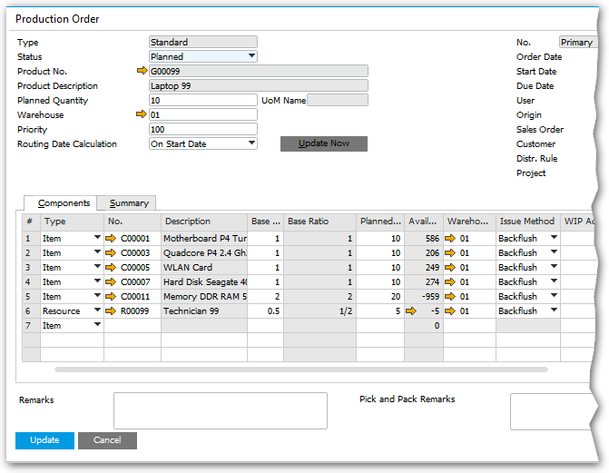

When the issue method is set to Manual, the user first needs to release the component items by adding an issue for production document. When production is complete, the user then enters a receipt from production document to add the item produced into inventory.

Information: The Manual method is usually used when the production time at hand is long and the exact inventory level needs to be up-to-date in the system at all times.

Close the production order by changing the status to Closed:
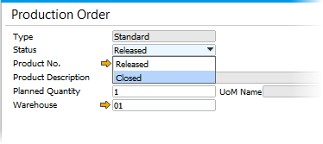

Task 5
Which report can display the inventory transaction and the inventory level of the item produced?

Answer: (One way to achieve this is to execute a posting list report for the item through the context menu of the laptop item master data.)

